AI-Based Early Detection of Dementia Using Cognitive, Speech, and Behavioral Analysis
Piruthvi Raj S  School of CSE  Presidency University,  Bengaluru-560064, India.  dexty8147@gmail.com | Revanth Adithya V  School of CSE  Presidency University,  Bengaluru-560064, India.  vankarevanthadithya@gmail.com | Rafael V  School of CSE  Presidency University,  Bengaluru-560064, India.  rafeleya144@gmail.com

Abstract
Dementia is a progressive neurological disorder that affects memory, thinking ability, and behaviour. Early detection is essential to slow disease progression and improve patient care. However, traditional diagnostic methods often detect dementia only in advanced stages due to the lack of accessible and affordable screening tools. This research proposes an Artificial Intelligence-based system capable of analysing cognitive performance, speech patterns, and behavioural indicators to identify early signs of dementia.

Machine learning algorithms are applied to datasets containing speech recordings, cognitive test results, and behavioural patterns to classify individuals at risk. The system provides an early risk assessment tool that assists healthcare professionals in recommending further clinical evaluation. The proposed model aims to provide a scalable, non-invasive, and cost-effective solution for early dementia screening.

This research proposes an Artificial Intelligence-based system capable of analysing cognitive performance, speech patterns, and behavioral indicators to identify early signs of dementia. Machine learning algorithms are applied to datasets containing speech recordings, cognitive test results, and behavioral patterns to classify individuals at risk. The system provides an early risk assessment tool that assists healthcare professionals in recommending further clinical evaluation.
INTRODUCTION
Dementia is a neurodegenerative disorder affecting millions of elderly individuals worldwide. It results in cognitive decline, memory impairment, and difficulties in communication and daily functioning. According to the World Health Organization, dementia is one of the leading causes of disability among older adults.
Early detection plays a crucial role in managing dementia, as timely intervention can delay disease progression and improve quality of life. However, early symptoms such as mild memory loss, speech irregularities, and subtle behavioural changes are often difficult to detect using traditional diagnostic techniques.
Recent advancements in Artificial Intelligence (AI) and Machine Learning (ML) provide promising opportunities for developing automated screening tools. AI-based systems can analyse large datasets and identify patterns that may not be noticeable to human clinicians.
This research proposes an AI-powered software system designed to detect early-stage dementia by analysing cognitive tests, speech features, and behavioural patterns. The system aims to support early screening and assist healthcare professionals in identifying individuals who may require further clinical assessment.
This research contributes by developing an integrated AI-based framework that combines cognitive testing, speech analysis, and behavioral monitoring to provide an accessible early dementia screening tool.

Literature Survey
Several studies have explored the use of Artificial Intelligence (AI) and Machine Learning (ML) techniques for the early detection of dementia and Alzheimer’s disease.
These approaches aim to identify subtle cognitive and behavioural patterns that may indicate early neurological decline before severe symptoms appear.
Researchers have used machine learning algorithms to analyse speech and language patterns to detect cognitive impairment. Studies such as Fraser et al. [4] demonstrated that linguistic and acoustic features including speech pauses, reduced vocabulary richness, slower speech rate, and irregular sentence structures can serve as early indicators of dementia. Speech-based analysis is considered a non-invasive and scalable approach that allows continuous monitoring of cognitive health.

Other studies have focused on cognitive assessment tools that evaluate memory, attention, and reaction time through digital tests. These cognitive tests measure behavioural indicators associated with neurological decline and provide structured datasets for machine learning models. Research using datasets such as the Alzheimer’s Disease Neuroimaging Initiative (ADNI) has applied algorithms like Random Forest, Support Vector Machines (SVM), and Gradient Boosting to classify individuals at risk of developing dementia.

Recent advancements in deep learning techniques have further improved the accuracy of dementia detection systems. Neural network architectures and ensemble learning methods have demonstrated higher classification performance compared to traditional statistical models. Several studies report significant improvements in early-stage dementia prediction using multimodal data such as speech recordings, cognitive tests, and medical imaging.

Fraser et al.
Despite these advancements, many existing solutions rely heavily on clinical datasets, neuroimaging technologies, or specialized medical equipment, which may limit accessibility and increase the cost of screening. As a result, there is a growing need for more accessible AI-based screening systems that can analyse easily obtainable data such as speech patterns and cognitive assessments.

Therefore, this research proposes an AI-based system that integrates speech analysis, behavioural indicators, and cognitive testing to provide an early risk assessment for dementia.
The proposed approach aims to develop a scalable, non-invasive, and cost-effective solution that can support early detection and encourage timely medical consultation.

Objectives
The system that is suggested will be able to give the following results :
- Develop an AI-based system for early dementia risk detection:
This objective focuses on designing an intelligent system that uses machine learning algorithms to analyze user data and identify potential signs of dementia. The system aims to detect early cognitive decline by recognizing patterns that indicate possible neurological impairment. Such early detection can assist healthcare professionals in recommending further medical evaluation.
- Analyze cognitive performance using digital cognitive tests:
Digital cognitive tests are used to evaluate important mental abilities such as memory, attention, and problem-solving skills.
These tests collect measurable data that can indicate changes in cognitive performance over time. The collected results are analyzed using AI models to identify patterns that may signal early dementia risk.
- Extract speech features and detect irregular speech patterns:
Speech analysis is used to detect subtle linguistic and acoustic changes that may occur in individuals with early cognitive decline.
Features such as speech pauses, speaking rate, vocabulary complexity, and pronunciation patterns are extracted from voice recordings. Machine learning algorithms then analyse these features to identify abnormalities linked to dementia.
- Evaluate behavioral indicators associated with cognitive decline :
Behavioral indicators such as reaction time, decision-making patterns, and response accuracy can provide valuable insights into neurological health. The system evaluates these indicators through structured digital activities and behavioral data analysis. Detecting unusual behavioral patterns helps in identifying early warning signs of dementia.
- Provide an early risk assessment tool for healthcare professional :
The proposed system generates a risk assessment report based on analyzed cognitive, speech, and behavioral data. This report helps healthcare professionals understand whether a patient may be at risk of dementia. It serves as a preliminary screening tool that supports medical decision-making but does not replace professional diagnosis.
- Improve accessibility to dementia screening :
Many traditional dementia diagnostic methods require specialized equipment and clinical visits, which can limit accessibility. The proposed AI-based solution aims to provide a simple and user-friendly screening tool that can be accessed through web or mobile platforms. This approach allows more individuals to undergo preliminary cognitive screening.
- Reduce delay in clinical diagnosis :
Early dementia symptoms often go unnoticed, leading to delayed diagnosis and treatment. By providing an automated screening system, individuals at potential risk can be identified earlier. This can encourage timely medical consultation and improve the effectiveness of treatment and care.

II. Figures and tables
Figures and tables are essential components of this report, as they visually represent the structure, workflow, and performance of the proposed AI-based dementia detection system. These illustrations help in clearly conveying the technical foundation and research contributions of the study.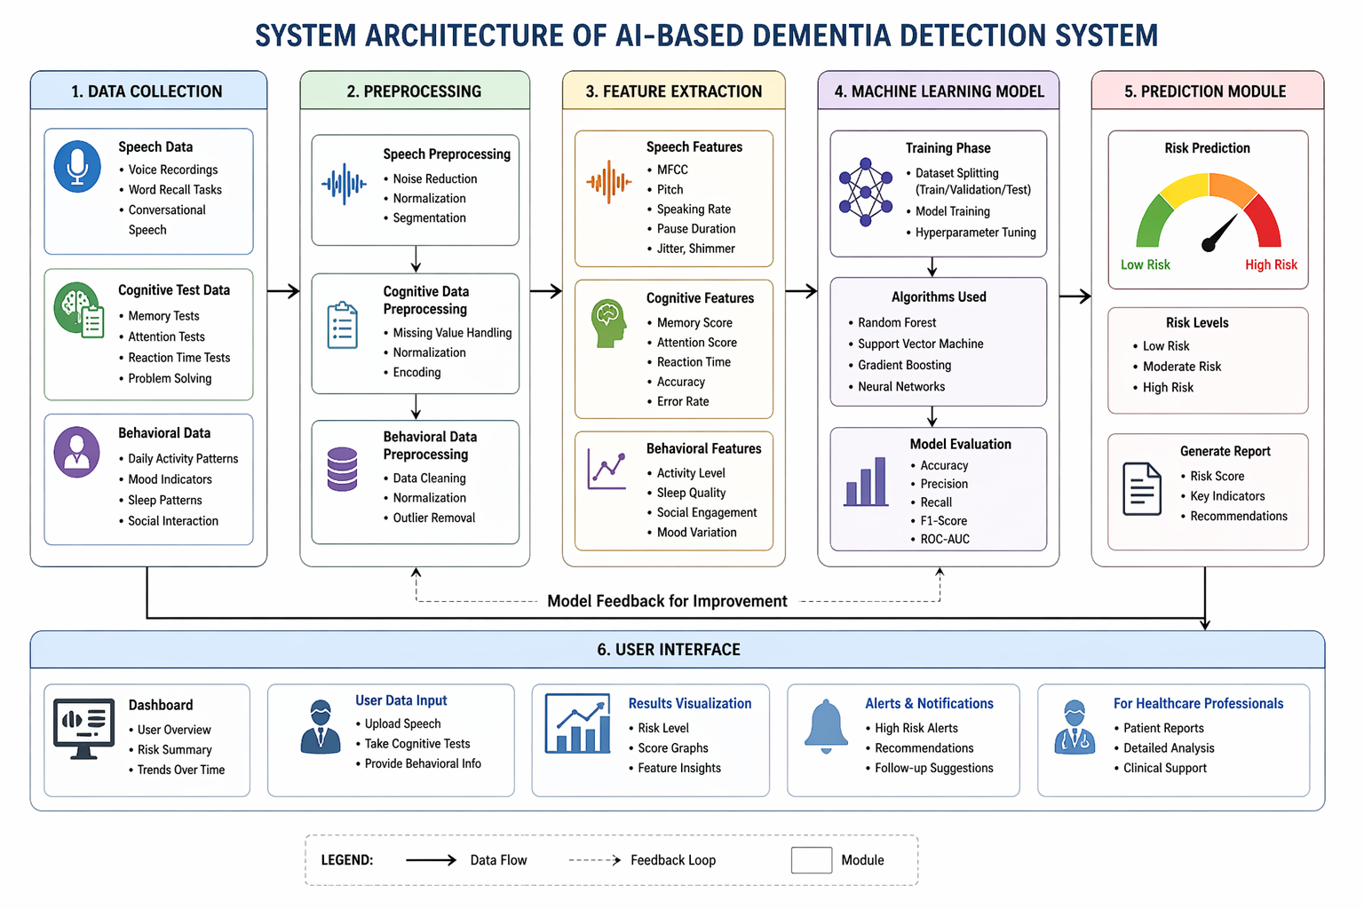Fig. 1. System architecture of the proposed dementia detection system.

Figure 1 presents the system architecture diagram of the proposed dementia detection system. It illustrates the interaction between key modules such as Data Collection, Preprocessing, Feature Extraction, Machine Learning Model, Prediction Module, and User Interface. The figure provides a clear understanding of the data flow and functional relationships within the system.
Table 1
The Components of The System Architecture
Module | Core Function
Data Collection | Collects speech, cognitive, and behavioral data.
Preprocessing | Cleans and normalizes input data
Feature Extraction | Extracts relevant patterns from speech and test data.
Machine Learning Model | Predicts dementia risk using trained models
Prediction Module | Classifies output (Low / Medium / High risk)
User Interface | Displays results in an easy-to-understand format

The table summarizes the major components of the system and their respective roles.
It demonstrates how each module contributes to accurate and efficient early detection of dementia.
The findings of the study are presented through both textual explanations and visual representations such as diagrams and tables. The system architecture diagram is particularly significant as it clearly illustrates the structural and functional workflow of the proposed solution. All visual elements are designed in accordance with IEEE standards to ensure clarity, readability, and proper documentation.

Existing methods and limitations
Currently, dementia is diagnosed using traditional medical approaches such as manual cognitive tests, questionnaires, clinical interviews, and brain imaging techniques like MRI and CT scans. These methods rely heavily on the expertise of trained medical professionals to analyses patient responses and identify signs of cognitive decline. While these approaches are effective in later stages, they often fail to detect early symptoms due to their subtle nature.
However, these methods have several limitations. The diagnostic process is time-consuming and expensive, making it inaccessible for many individuals. It requires specialized healthcare professionals and advanced medical equipment, which are not always available in all regions. Additionally, dementia is often detected at a later stage, reducing the effectiveness of early intervention. These challenges highlight the lack of scalability and accessibility in traditional diagnostic systems.
Due to these limitations, early-stage dementia detection remains difficult. Traditional approaches are not efficient in identifying minor cognitive changes and require significant time, cost, and expertise. This creates a strong need for an intelligent, automated, and scalable solution that can assist in early detection.
Limitations Acknowledged
Existing methods for dementia detection suffer from several important limitations. There is limited accessibility for many users, especially those who lack access to advanced healthcare facilities or digital tools. Current systems do not provide continuous monitoring or systematic tracking of a patient’s cognitive changes over time. Additionally, many existing solutions offer outdated or fragmented user interfaces, making them difficult to use and less effective in real-world scenarios.
Furthermore, there is a lack of integration between different diagnostic approaches such as speech analysis, cognitive testing, and behavioural monitoring. These methods often operate independently rather than as part of a unified system. As a result, early-stage symptoms may go unnoticed, and the overall diagnostic process becomes less efficient.
These limitations reduce the effectiveness, scalability, and accessibility of dementia detection systems. They highlight the need for an intelligent, integrated, and automated solution that can provide early, accurate, and user-friendly assessment of cognitive decline.

proposed methodology
To address the above limitations, an AI-based automated system is proposed for early detection of dementia. The system integrates data processing, machine learning, and user interaction into a single unified platform. It utilizes modern technologies to analyses speech patterns, cognitive test results, and behavioural indicators.
By combining these components into one environment, the system enables efficient data analysis, real-time processing, and accurate risk prediction. This approach improves accessibility, reduces dependency on manual diagnosis, and provides a scalable solution for early dementia screening. The proposed system ensures a more streamlined, intelligent, and user-friendly method for detecting cognitive decline at an early stage.
A. System Modules
1. Data Collection
Data will be collected from publicly available datasets containing:
- Speech recordings
- Cognitive assessment results
- Behavioural indicators
2. Data Preprocessing
The collected data undergoes preprocessing including:
- Data cleaning
- Normalization
- Feature extraction
3. Feature Extraction
Important features are extracted from speech and cognitive data, including:
- Speech pause frequency
- Speech rate
- Vocabulary complexity
- Memory test accuracy
- Reaction time measurements
4. Machine Learning Model
Supervised learning algorithms are used for classification. Possible models include:
- Random Forest
- Support Vector Machine
- Neural Networks
- Logistic Regression
5. Prediction and Risk Assessment
The trained model predicts the likelihood of early dementia risk and provides a classification output indicating low, moderate, or high risk.
B. Process Flow
The system processes datasets consisting of speech recordings, cognitive test results, and behavioural indicators. These datasets are collected from publicly available research sources and preprocessed before being used for machine learning model training. Using this data, combined with the continuous automated report generated by scripts, is constantly changing and optimizing running campaigns.

System Architecture
The system architecture consists of the following modules:
- User Interface Module
  - Web or mobile interface for assessments
- Data Processing Module
  - Data cleaning and feature extraction
- Speech Analysis Module
  - Voice feature extraction and pattern recognition
- Cognitive Testing Module
  - Digital memory and reaction tests
- Machine Learning Module
  - Model training and prediction
- Result and Reporting Module
  - Displays risk assessment results

IMPLEMENTATION AND TOOLS USED
The implementation of the proposed AI-based dementia detection system utilizes modern development frameworks and cloud infrastructure to ensure efficiency, scalability, and reliability. The technologies used in the system are as follows:

1. Programming & Core Frameworks
- Python: The primary language used for backend logic.
- Flask or Fast API: Used to build the backend server that handles requests.
- JavaScript: Powering the clinical logic, patient intake, and assessment features in the frontend.

2. Machine Learning & Speech Processing
- TensorFlow, PyTorch, & Scikit-learn: These frameworks are used for diagnostic processing and AI risk assessment.
- Librosa: A specific library used for analyzing patient vocal data.

3. Frontend & UI/UX
- Tailwind CSS: Used for the modern, clean styling and the "hero-mesh" backgrounds.
- Plus, Jakarta Sans: The specific Google Font integrated for a professional clinical look.
- Font Awesome: For all the iconography, such as the brain and microphone icons.

4. Integrated Libraries & Deployment
- html2pdf.js: A key library added to allow both doctors and patients to download results as PDFs.
- GitHub: Your version control is managed through the repository revadithya/DPDJourn.git.
- Cloud Hosting: The project is designed to be deployed on AWS, Google Cloud, or Azure.

Conclusion and Future-work
The proposed AI-based system provides a non-invasive, efficient, and scalable method for early dementia detection. It analyses speech patterns, cognitive tests, and behavioural indicators to identify subtle changes. Capable of detecting early signs often missed in traditional clinical assessments. Machine learning enables faster and more accurate risk assessment. Supports healthcare professionals in timely and informed decision-making. Reduces reliance on expensive tests and specialized expertise. Improves accessibility for a larger population. Enables proactive intervention and reduces diagnostic delays. Enhances patient outcomes through early detection.

Future Improvements
- Integrate advanced deep learning models for better accuracy.
- Implement real-time speech analysis using NLP techniques.
- Develop a mobile application for accessibility and continuous monitoring.
- Add multilingual support for wider usability.
- Integrate with wearable devices/sensors for continuous data collection.
- Perform clinical validation with healthcare institutions.
- Implement secure cloud-based infrastructure for large-scale deployment.
- Improve data management and remote accessibility.
- Enhance system to be more robust, scalable, and practical for real-world use.

References
[1] World Health Organization, Dementia – Key Facts, 2023.
[2] Alzheimer’s Association, What Is Dementia?, 2024.
[3] M. Gauthier et al., Artificial Intelligence in Early Detection of Dementia, Journal of Medical Systems, vol. 45, no. 3, 2021.
[4] A. Fraser et al., Detecting Cognitive Decline Using Speech and Language Analysis, IEEE Journal of Biomedical and Health Informatic, 2020.
[5] Scikit-learn Developers, Machine Learning in Python, 2024.
[6] TensorFlow, An End-to-End Open Source Machine Learning Platform, 2024.
[7]. Librosa Developers, Librosa : Audio and Music Signal Analysis in Python, Librosa Documentation.
Available: https://librosa.org

[8]. Google Research, Speech Recognition and Cognitive Analysis Using AI, Google AI Blog.
Available: https://ai.googleblog.com

[9]. ChatGPT, OpenAI, AI-assisted Research and Content Generation Tool, OpenAI .
Available: https://www.openai.com

[10]. Petersen, R. C., Early Diagnosis of Alzheimer’s Disease: Is MCI Too Late ?, Current Alzheimer Research, vol. 6,no. 4, pp. 324–330, 2009.

[11]. Jack, C. R. et al., NIA-AA Research Framework: Toward a Biological Definition of Alzheimer’s Disease, Alzheimer’s & Dementia, vol. 14, no. 4, pp. 535–562, 2018.

[12]. Shah, S. et al., A Survey on Machine Learning Techniques for Dementia Detection, Computer Methods and Programs in Biomedicine, vol. 189, 2020.

[13]. López-de-Ipiña, K. et al., Analysis of Speech and Language for Early Detection of Alzheimer’s Disease, Neurocomputing, vol. 150, pp. 392–402, 2015.

